**DATABASE SQL QUERIES FOR THE DATASET**

**ROSE MAKANDA**

Count of Different Types of Content:

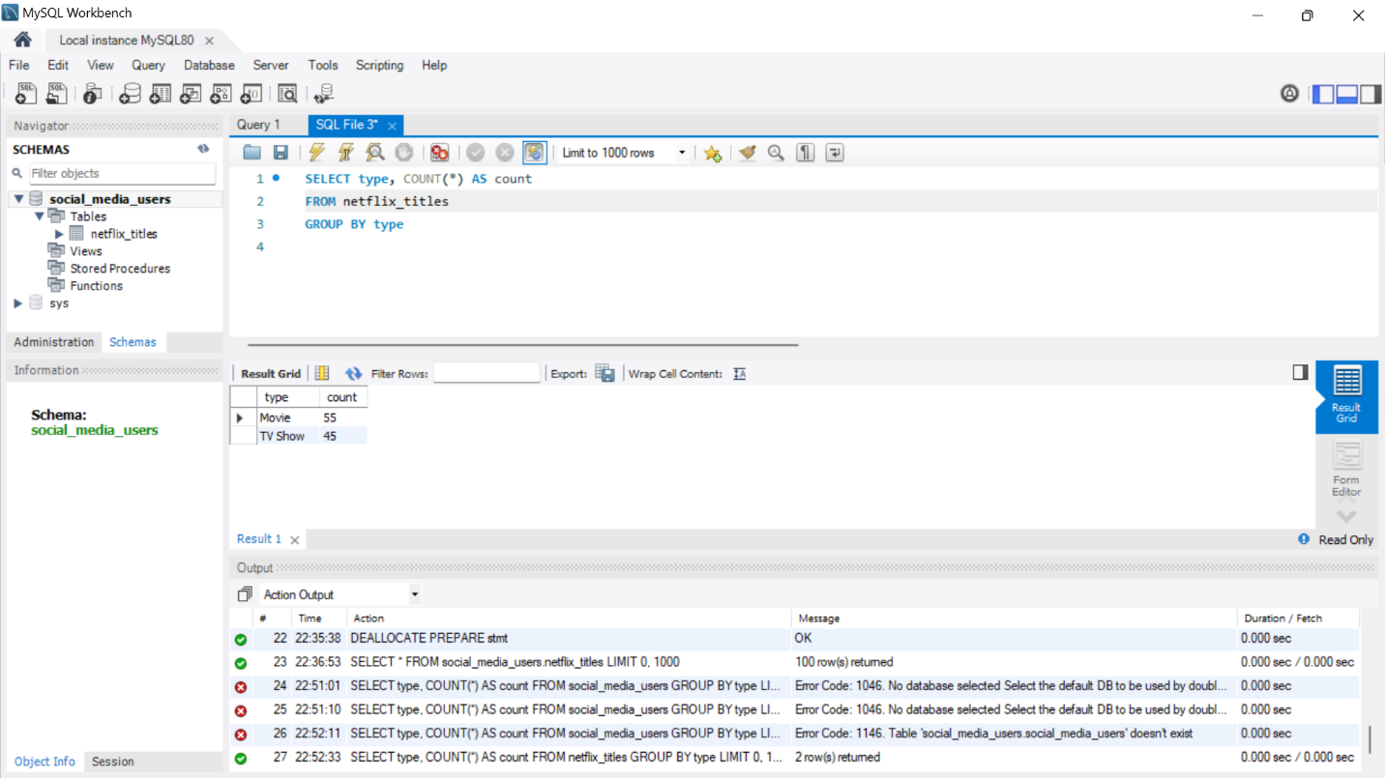

Top 5 Countries with the Most Content:

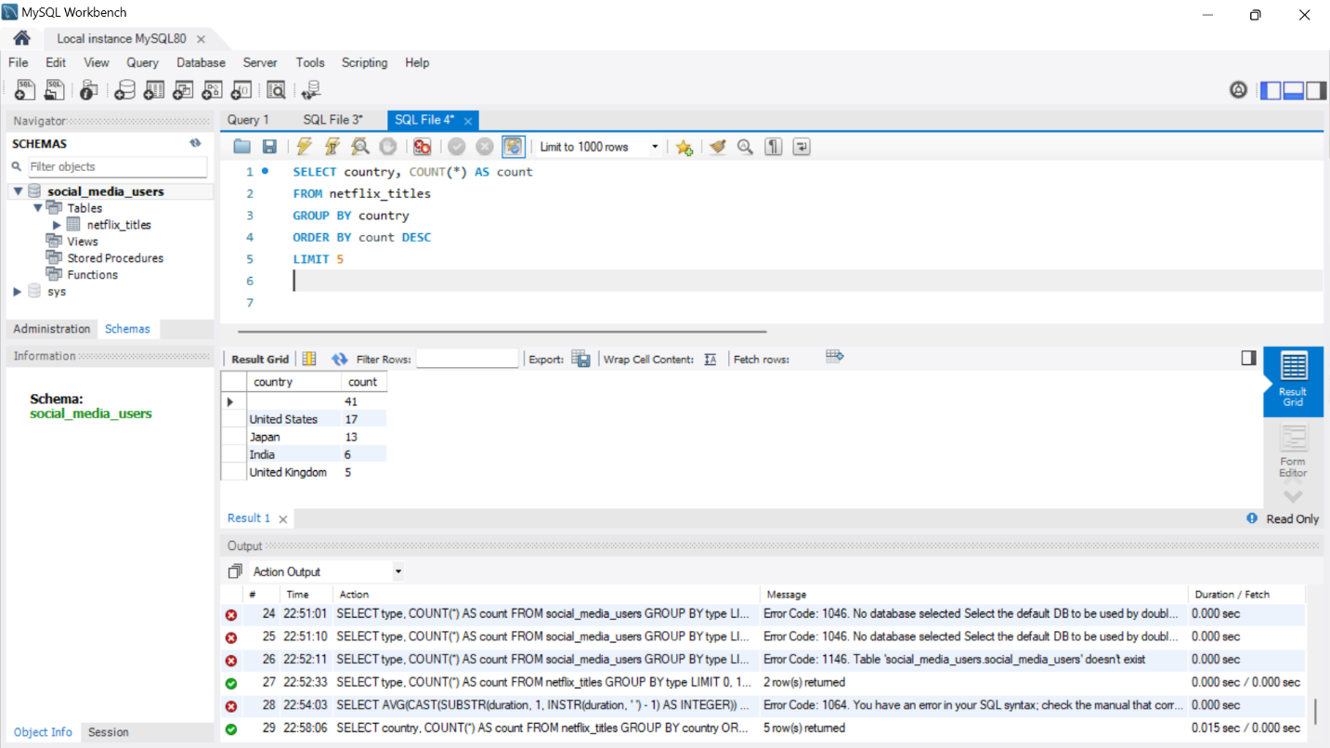

Question 1: What are the top 5 most recent movies added to Netflix?

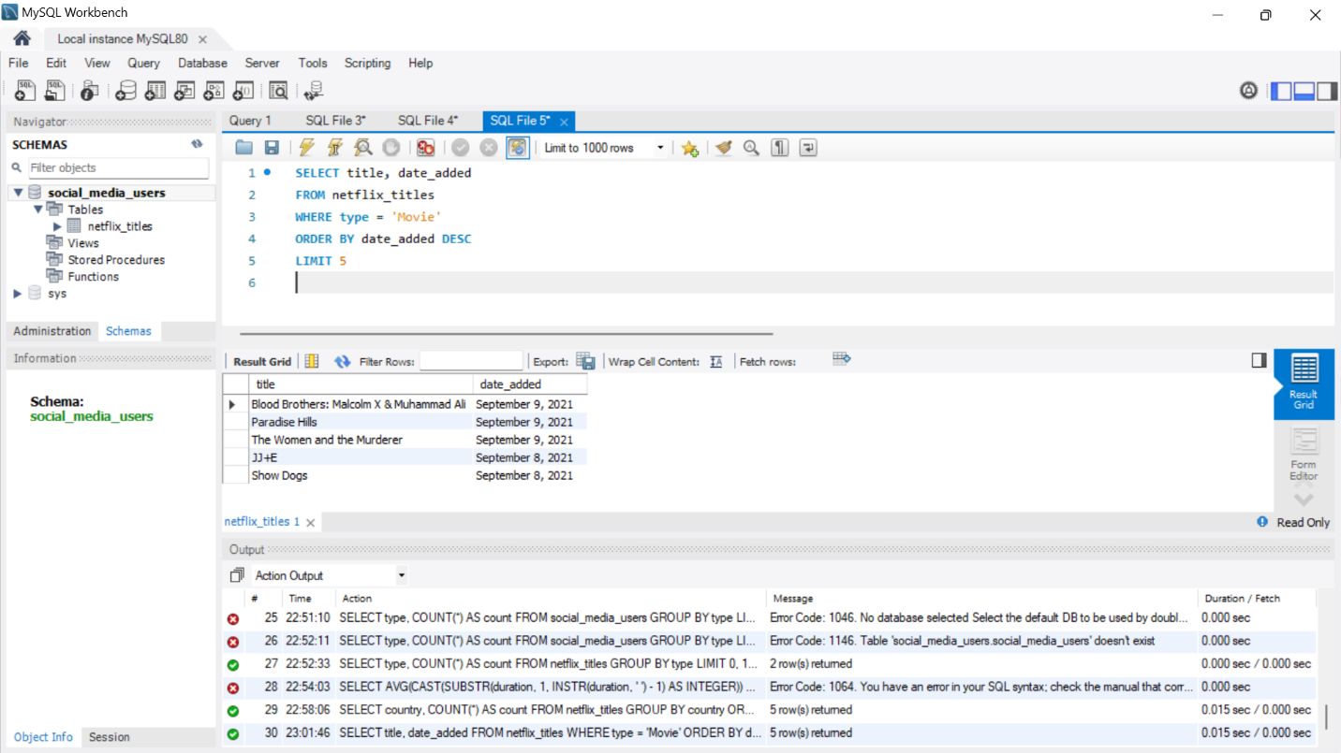

Question 2: What are the top 5 genres listed most frequently in the dataset?

